Smart Cricket Bat

Gavin Dahl, Jiakai Hu, Pablo Barron, Nolapat Pipitvitayakul

**Execution Plan**

**Execution Plan for the Smart Cricket Bat**

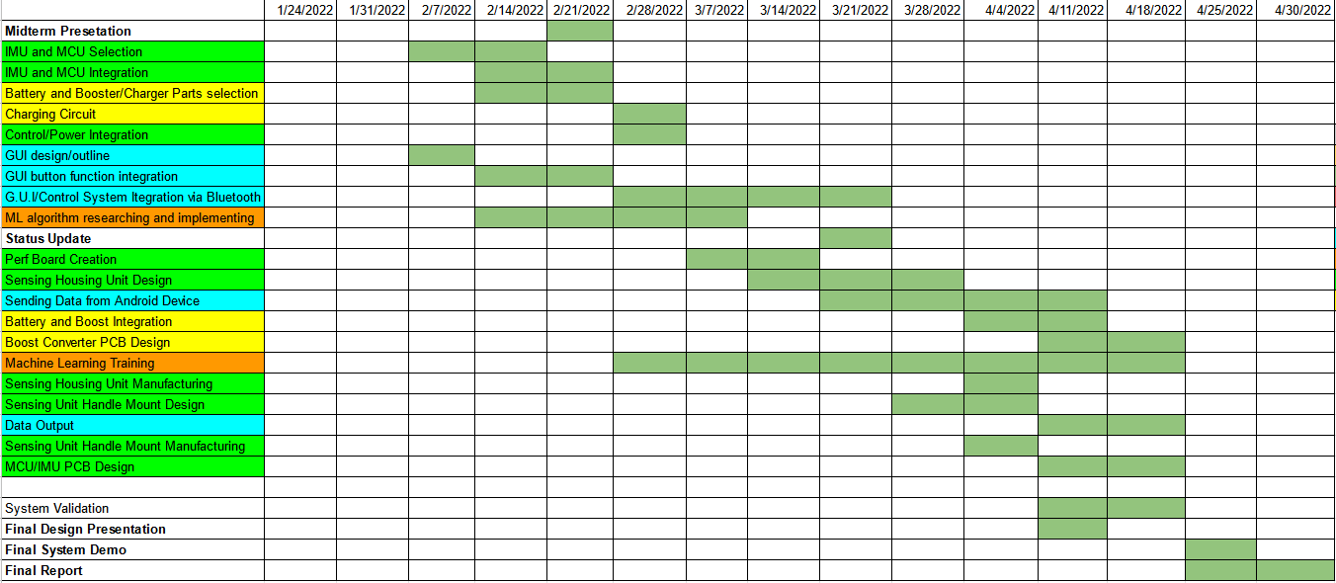

Legend

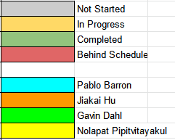

Smart Cricket Bat

Gavin Dahl, Jiakai Hu, Pablo Barron, Nolapat Pipitvitayakul

**Validation Plan**

**Validation Plan for the Smart Cricket Bat**

| Test Name | Success Criteria | Methodology | Status | Responsible Engineer(s) |
| --- | --- | --- | --- | --- |
| Sending Data via Android device | The app should be able to send data (input for ML Algorithm) | Upload the app to a simulated android phone and test by outputting data to a localized device to test data sending | IN PROGRESS: App is able to send data to a device via an input stream | Pablo Barron |
| ML Algorithm Precision | The ML algorithm provides precise results of output data within acceptable error range. | Use all data gathered to test the training and testing accuracy. | TESTED: Training accuracy around 98% and Testing accuracy around 13% | Jiakai Hu |
| Communication Range | Communication between the sensing unit and app stays active for a distance of up to 100ft. | Test normal functionality of the smart cricket bat's operations at 5ft intervals ranging from 0ft to 100ft. | IN PROGRESS: Bluetooth successfully connected in a radius of 10 feet | Gavin Dahl Pablo Barron |
| System Latency | User swing analysis deliver to user via the app in no greater than 10s after the user's bat has struck the ball. | Take 20 practice swings with the bat, timing the time from the ball's impact on the cricket bat till the analyzed swing data is available to user on app. | UNTESTED | Full Team |
| Wireless Connection Stability | Connection between sensing unit and smartphone app does not drop. | Sensing unit connected to smartphone app via bluetooth, set to default mode, and left to run for 1 hour. Connection is monitored via smart phone app. | IN PROGRESS | Gavin Dahl Pablo Barron |
| Full Range of Motion | Sensing unit can measure the angle of the bat at a full 360°. | Sensing unit is attached to pivoting arm on a protracter, the angle is tracked on both a piece of paper and in a text file, and then compared. | TESTED: Sensing unit tracks accurate degree of turn for all 3 axes | Gavin Dahl |
| Easy to Use GUI | The app is easily navigable to allow any person, regardless of technical skills, to use our device | Upload the app to a simulated android phone to view the clarity of the app | TESTED: App is able to run on physical device and does not crash | Pablo Barron |
| Operation Time | System operates continuously on battery power for a minimum of 2 hours. | Sensing unit is turned on, set to default mode, and left to run for 2 hours. Power is monitored via a digital multimeter. | TESTED: Fully charged battery connected to boost converter with load current of 50 mA can run for 2:15 hours | Nolapat Pipitvitayakul |
| Detection Range | Sensing unit can detect vibrations from at least 38in away when mounted on a bat. | Mount sensing unit on end of the cricket bat handle and hit the top of the bat 10 times to ensure full range. | TESTED | Gavin Dahl |
| Detection Accuracy | Sensing unit is able to detect a collision between ball and bat on any area of the cricket bat. | Mount sensing unit on cricket bat, measure data from hits in a variety of areas on the bat (at least 15) until it is confirmed there are no dead areas. | TESTED | Gavin Dahl |
| Detection Sensitivity | Sensors are able to detect degrees of motion within 1deg of change and is able to give changes in speed to 1 decimal places. | Mount sensing unit to cricket bat, connect to PC via microUSB, use protractor to accurately gauge all 3 axes for IMU and compare, drop IMU from predetermined heights and compare values gotten with expected calculated results. | TESTED | Gavin Dahl |
| Ease of Use | System is easily attached to end of handle of the cricket bat, is easily connected to the app via bluetooth, and is easy to calibrated during first time start up calibrations. Whole process should take no more than 5 minutes. | Use stopwatch to measure how long it takes te user to mount device, pair to phone, and do the calibration setup. | IN PROGRESS | Full Team |
| Mass | Mass of combined control system (MCU and IMU sensors), power system (Li-Po Battery and boost converter), and our housing unit, will weigh no more than 100g. | Use digital scale to measure weight of combined unit. | UNTESTED | Nolapat Pipitvitayakul Gavin Dahl |
| Volume Envelope | The housing unit for the sensing device should a cylindrical shape, be no more than 60mm in diameter, with an interior diameter of 56mm, and a height of 35mm. | Measure inner and outer diameters and height of created housing unit for sensors. | UNTESTED | Nolapat Pipitvitayakul Gavin Dahl |
| Mounting | The sensing unit is able to be mounted to the handle of any cricket bat and can lock securely into place. | Use the developed mounting device to mount the sensing unit onto end of the handle of the bat, and do various shack and shock test to confirm secure fit. | UNTESTED | Nolapat Pipitvitayakul Gavin Dahl |
| Input Voltage (MCU) | The input voltage for our Beetle BLE board shall be between 5V - 8V. | Use multimeter to validate input voltage level. | TESTED: Boost Converter Output is 5V +- 0.1 | Nolapat Pipitvitayakul |
| Battery Charging Voltage and Current | The sensing unit has a 3.7V 150mAh Lo-Pi batteries as its power supply. These can be charged through a microUSB cable that can supply maximum 150mA of charge current with a 4.2V charge voltage. | Use multimeter to validate voltage levels and charge current levels. | TESTED: Charge voltage is 4.2 V and maximum charge current is 150 mA | Nolapat Pipitvitayakul |
| App Data Gathering via Bluetooth | The Android device should be able to receive data from our MCU via bluetooth | Upload the app to a simulated android phone and input different "dummy" data to see if the android device recieved the data | TESTED: Random Reading errors, but we are able to read data sent from the mcu | Pablo Barron |
| Thermal Resistance | The system should be able to operate in environments with temperatures ranging from 0°C to 85°C. | Use heating mechanism to raise temperature to 85°C and test systems functionality. Place system in cooling mechanism to lower temperature to 0°C and test systems. | UNTESTED | Gavin Dahl |
| Shock Tolerance | The IMU should be able to handle g shocks up to a max of 10,000g. | Test dropping IMU at differing heights and then use systems normal functionality to try to validate that IMU will still function after taking shocks more than 10,000 | IN PROGRESS | Gavin Dahl |

**Performance on Execution Plan**

The execution plan was executed completely. Although some tasks were actually performed somewhat out of order to accommodate the schedules of both teammates and the people operating the equipment used for the validation of the sensors, each task that was set forth in the execution plan was completed on time. The project was completed in full, with all of the objectives that were outlined at the beginning of the project demonstrated as required by the initial proposed solution.

**Performance on Validation Plan**

The validation plan is not complete yet, as we will need to validate a few more extremities once we move onto the next phase of creation. Data was collected on each of the different subsystems and their performance, in order to ensure that they will properly fulfill their individual function when integrated with the full system next semester. Although some difficulties were encountered, most notably the Bluetooth communication between the mobile device and the microcontroller, the different parts of the systems were tested to be reliable in the end, and the data acquired confirms this.